X Softball Assn Draft Budget for (insert year)
Insert Assn / Club logo here

OVERVIEW:

- This draft budget should be treated as a starting point and the methodologies and assumptions reviewed, not just the numbers.

- In preparation of this budget I have not / have not referred to any strategic documents or organisational objectives.

- Income is heavily relied on external controls (EG: grants). There is a high risk to operations if there is a significant shift in external funding.

WHY BUDGET?

- A budget is the success plan for an organisation.

- A budget helps you plan to reach goals within an organisation, making sure you are generating the income you need and are in control of the costs related to the activities.

- Performance monitoring

- Aligning financial capability/capacity in achieving strategic objectives.

- Help in funding applications.

- In setting appropriates fees and charges in delivering services.

KEY ASSUMPTIONS:

- A majority of the budgets have been aligned to forecasted 13/14 financial year expenditure.

- For ease of management and to associate costs to how they are funded three business units have been derived.

- Operations (funded via club fees and ………)
- Administration (funded via x Grant and residual income)
- Development (yet to be developed)
- Representative (Income matches expenses)
- Bar (Funded via purchases less related costs)

Forecasted Teams for the x season

Grade | Number of Forecasted Teams for 2014/2015
Total Teams

Proposed Fees 2014/2015 Schedule

Example

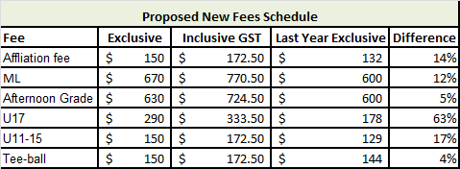

Actual

Proposed new Fees Schedule

Grade | Fee exclusive GST | Fee inclusive GST | Last yrs fees exclusive GST | % difference

Cost Matrix Fees (Operations Budget) –

The purpose to allocate costs to align with the benefits to each grade. (Operations budget)

Example: (breakdown what grades would be allocated what proportion of costs incurred so you can look at charging each grade accordingly)

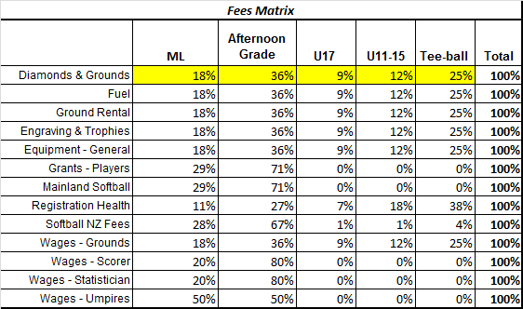

Actual:

Fees Matrix
 | Insert Grade | Insert Grade | Insert Grade | Insert Grade | Insert Grade | Total
Diamonds & grounds |  |  |  |  |  | 100%
Wages grounds |  |  |  |  |  | 100%
Wages admin |  |  |  |  |  | 100%
Wages scorer |  |  |  |  |  | 100%
Wages Statistician |  |  |  |  |  | 100%
Wages - umpires |  |  |  |  |  | 100%
SNZ fees |  |  |  |  |  | 100%
Equipment |  |  |  |  |  | 100%
Ground rental |  |  |  |  |  | 100%
Representative contribution |  |  |  |  |  | 100%
Training and development |  |  |  |  |  | 100%
 |  |  |  |  |  | 100%
 |  |  |  |  |  | 100%

Where do your fees go?

Example

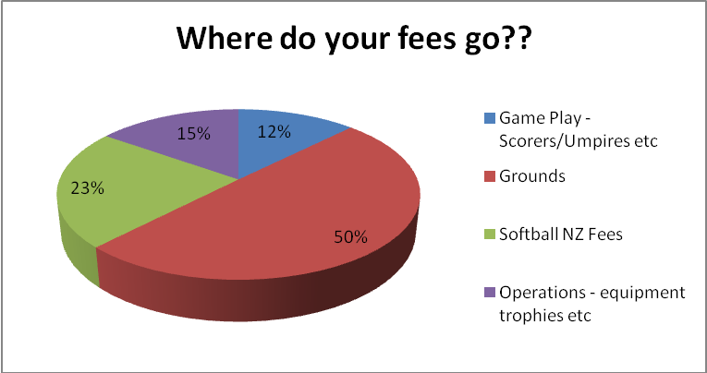

Recommended Changes –

Other/General expenses to be reviewed

